Installing MAPLE in local Desktop/Laptop:

Check the OS bit level by issuing the below command from the terminal.
#getconf LONG_BIT

For 32 bit OS:
=============
scp -r theory@172.16.2.220:/state/partition1/MAPLE/Linux <location to put the directory,eg: /home/ksgupta/SOFTWARE/>
passwd for the user “theory“ is “theory123”

Inside the “Linux” directory go to the location “Disk1/InstData/VM” and execute the below command.
#./Maple16Linux32Installer.bin

For 64 bit OS:
============
scp -r theory@172.16.2.220:/state/partition1/MAPLE/X86_64 <location to put the directory,eg: /home/ksgupta/SOFTWARE/>
passwd for the user “theory“ is “theory123”

Inside the “ X86_64” directory go to the location “Disk1/InstData/VM” and execute the below command
#./Maple16LinuxX86_64Installer.bin

Now follow the on-screen instructions as shown in the consequent screen-shots.
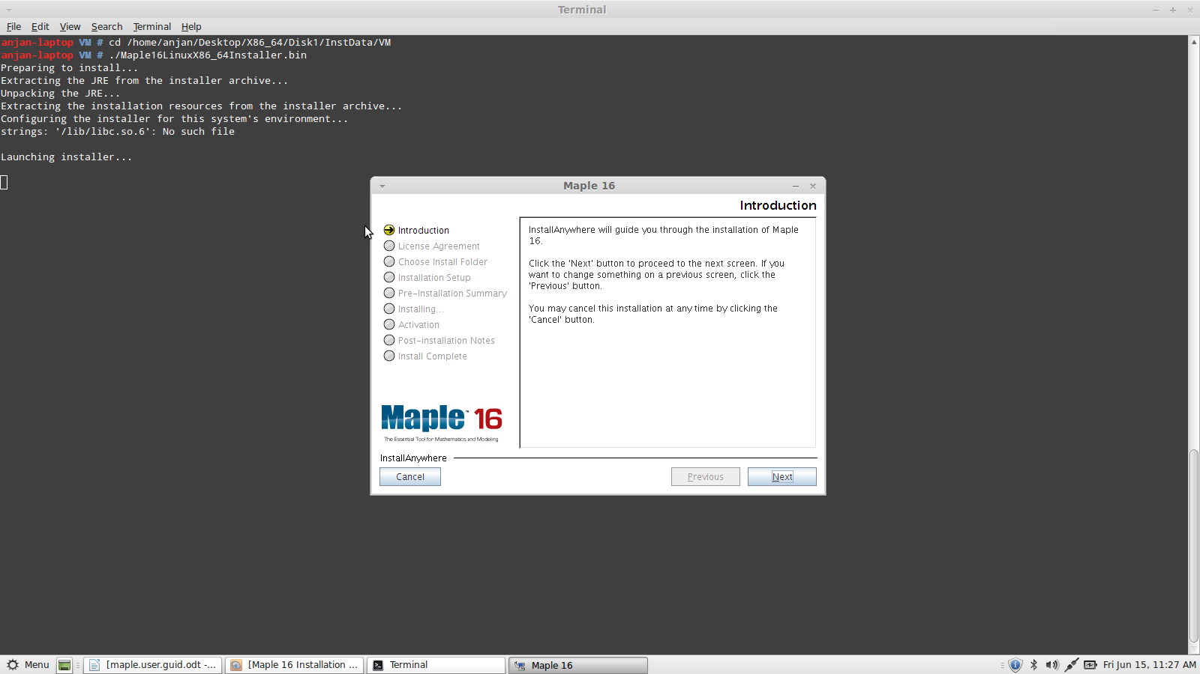
Screen-shot:1

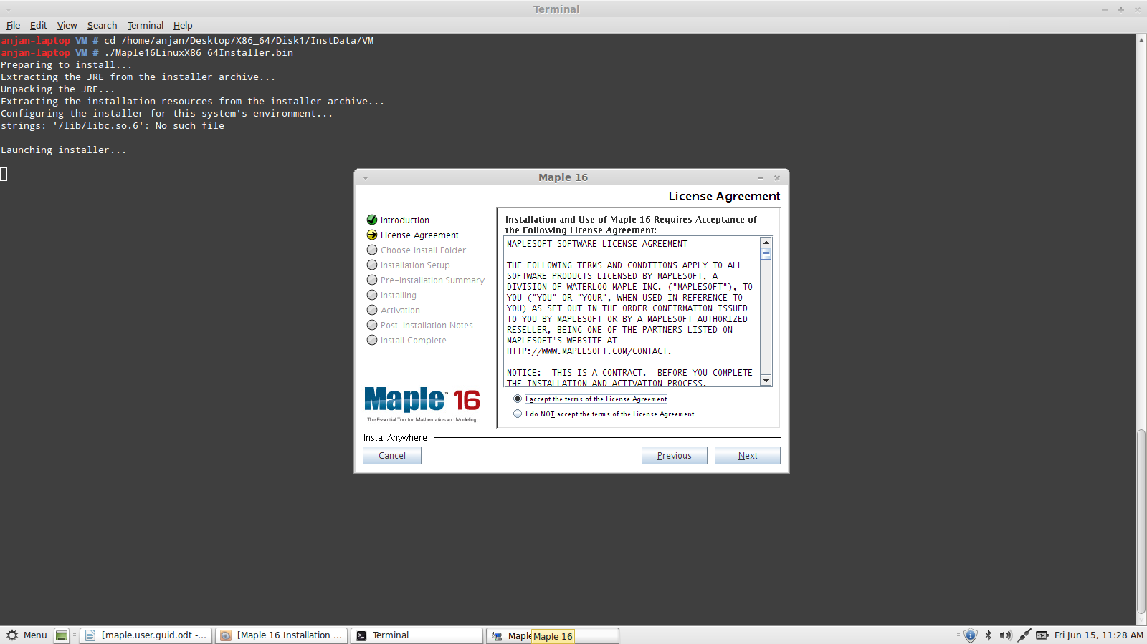
Screen-shot:2

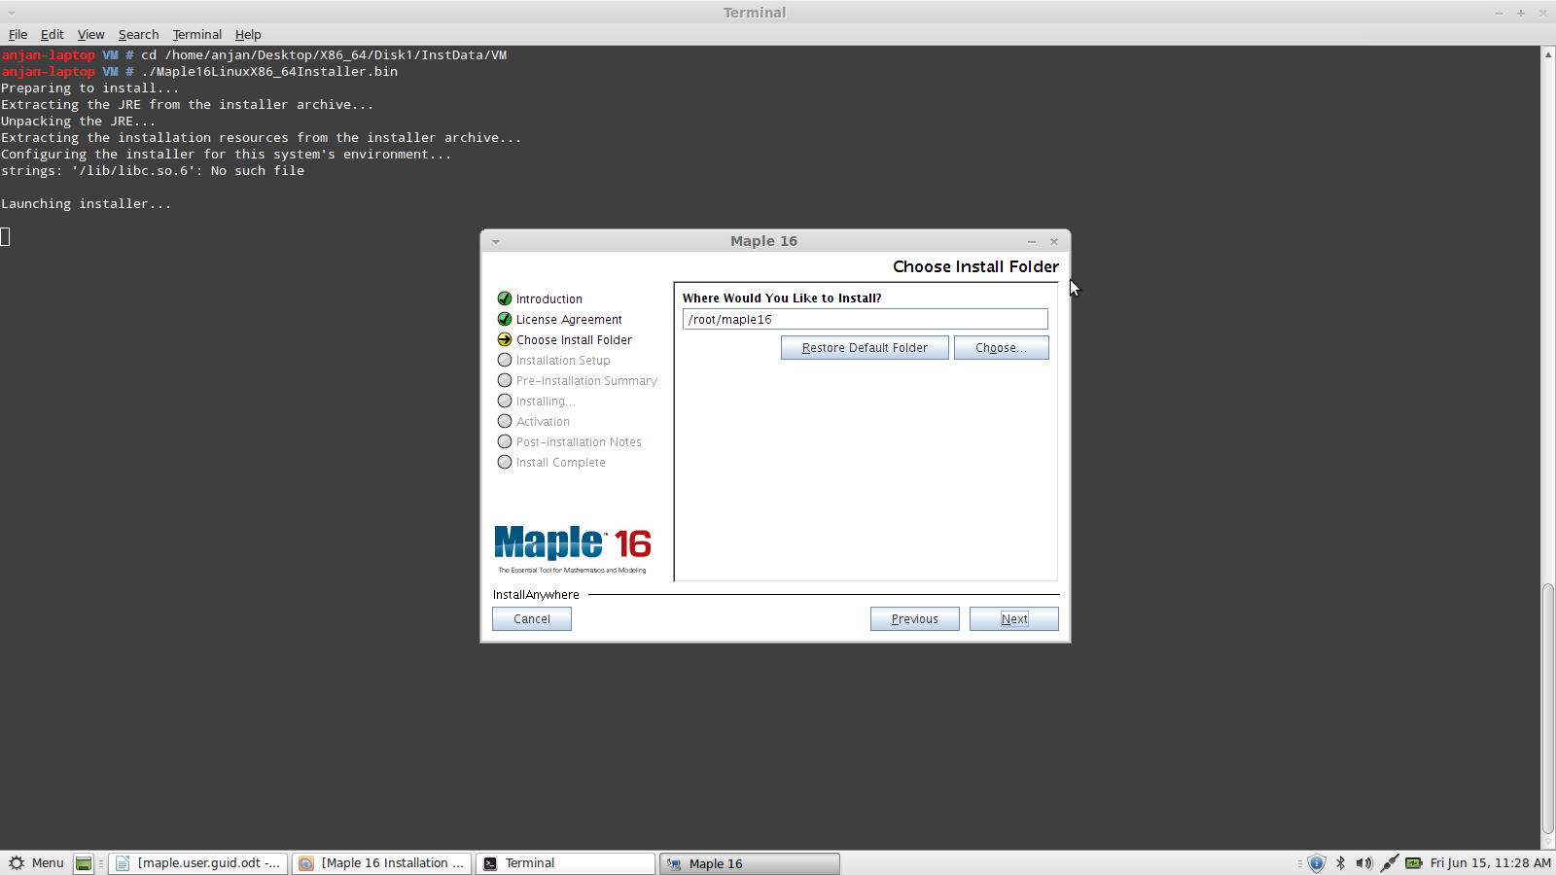
Screen-shot:3
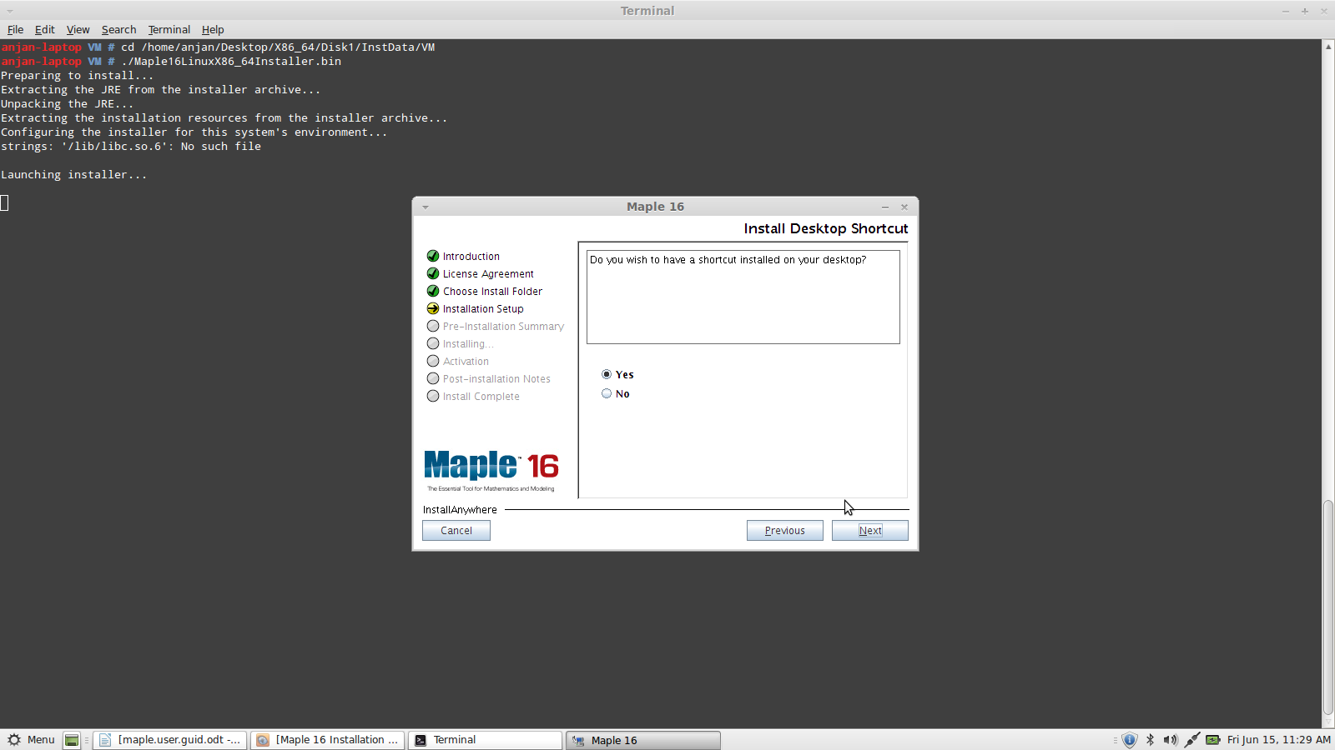
Screen-shot:4

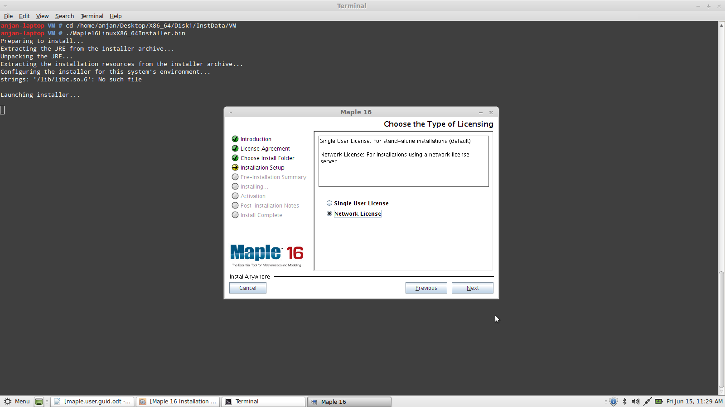
Screen-shot:5

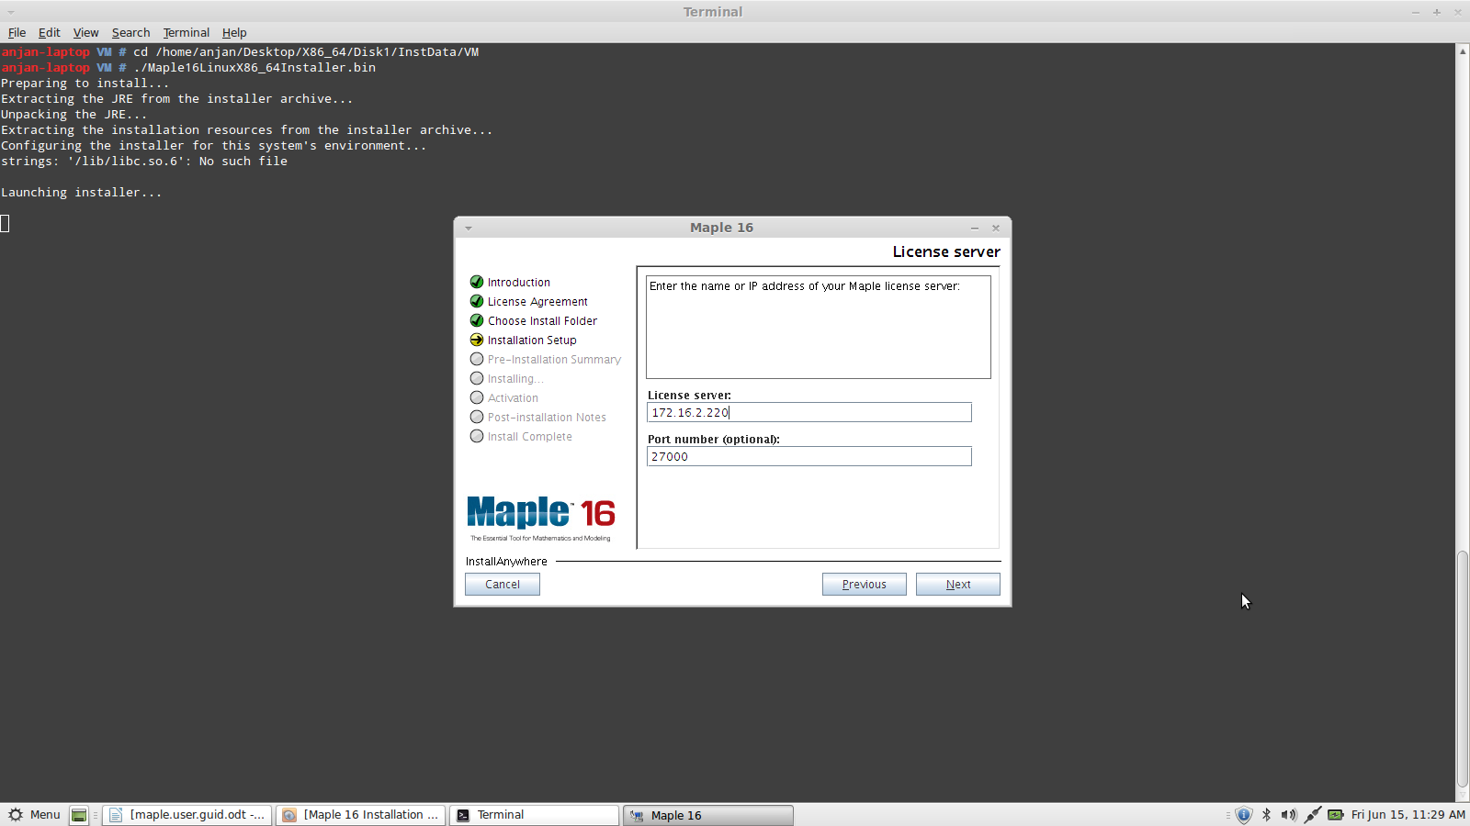
Screen-shot:6

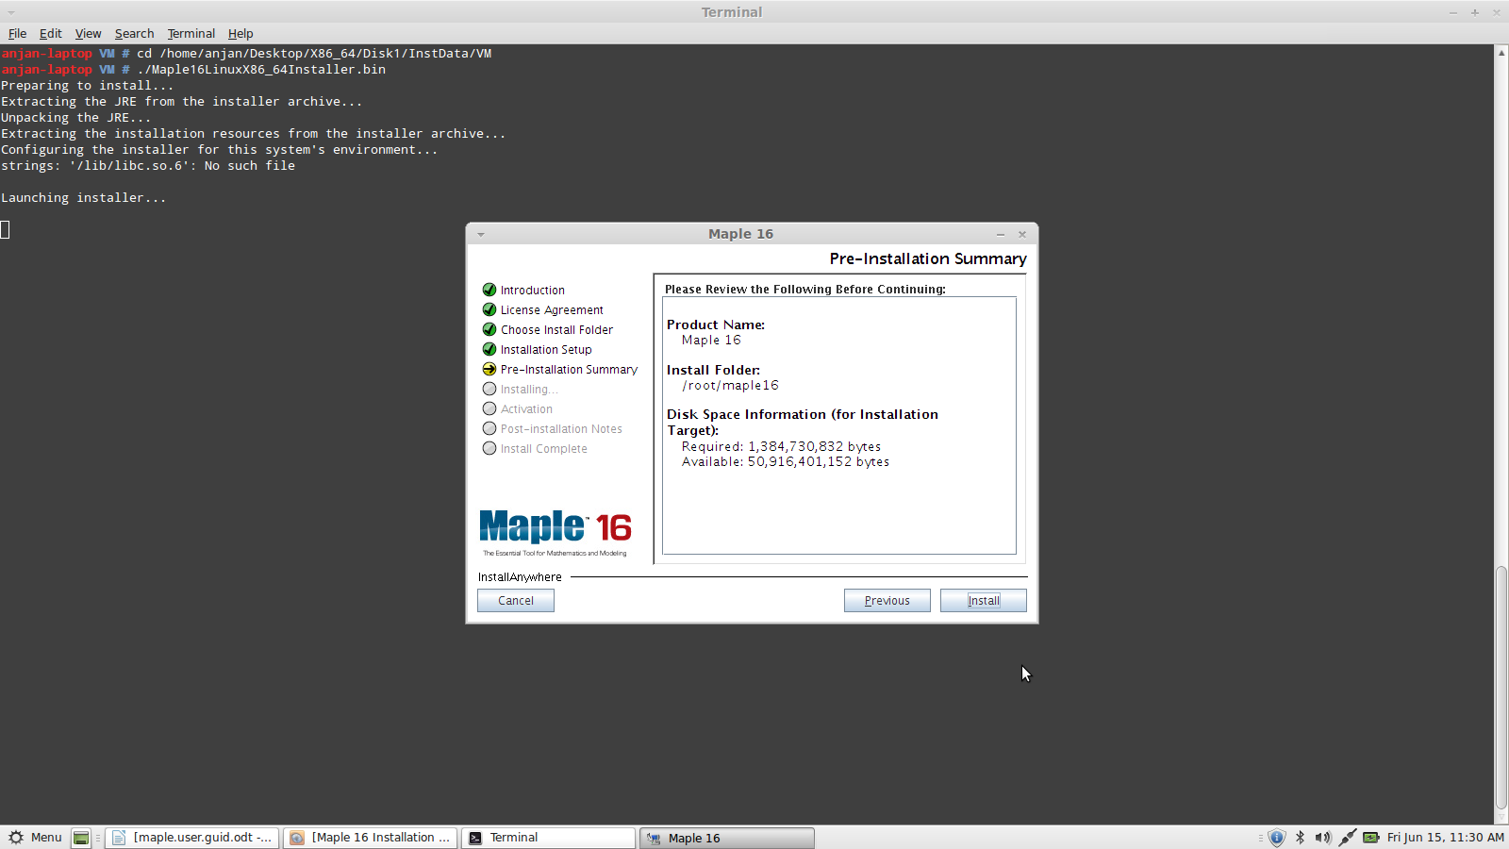
Screen-shot:7
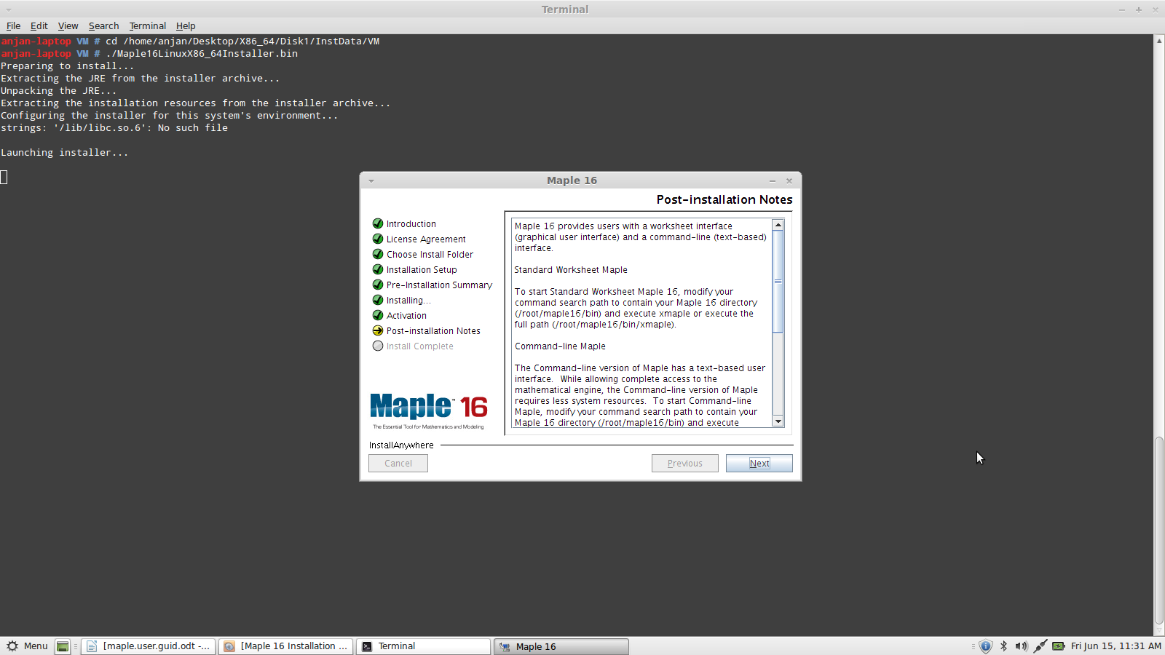
Screen-shot:8

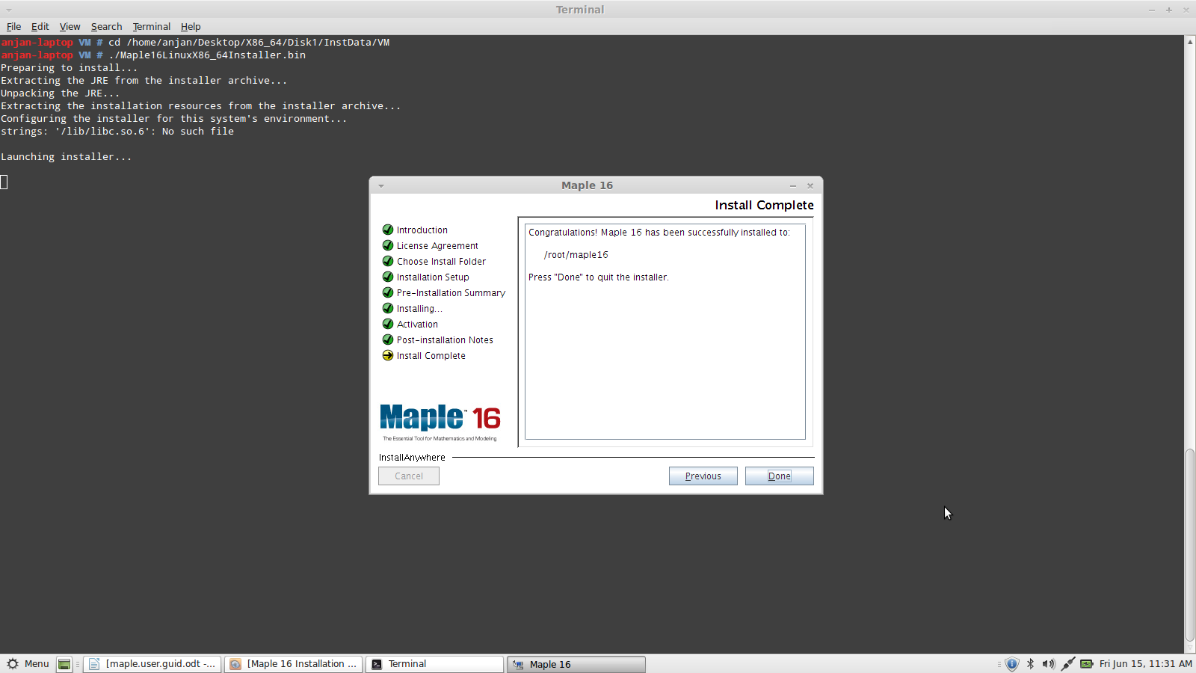
Screen-shot:9

Thus Maple is being installed in your local machine. To start Maple go to the “bin” directory under the installation path (eg:cd /root/maple16/bin) and execute the below command.
#./xmaple

or

write a simple script named “maple” and save it under “/bin” and invoke maple everytime only by typing “maple” in terminal.

#cd /bin
#vi maple (press “enter” to create the file and press “i” to insert the below commands in it)
cd /root/maple16/bin;
./xmaple;

Now press “Esc” and “:wq” to save and exit.

Now change the file permission and start maple.
#chmod +x maple
#maple

