Installing MATLAB in local Desktop/Laptop:

Step1: Copy the “MATLAB.DVD” directory from the node “Chandra” by issuing this command from your terminal.

#scp -r theory@172.16.2.220:/state/partition1/MATLAB.DVD <location to put the directory,eg: /home/ksgupta/SOFTWARE/>
passwd for the user “theory“ is “theory123”

Step2: Thus the directory “MATLAB.DVD is copied in your local machine. Now go inside the directory MATLAB.DVD (eg: #cd /home/ksgupta/SOFTWARE/MATLAB.DVD) and issue the below command to install matlab in your local machine.

#./install

In the Mathwork Installer window select “install without using network”option and click Next. (screenshot1)

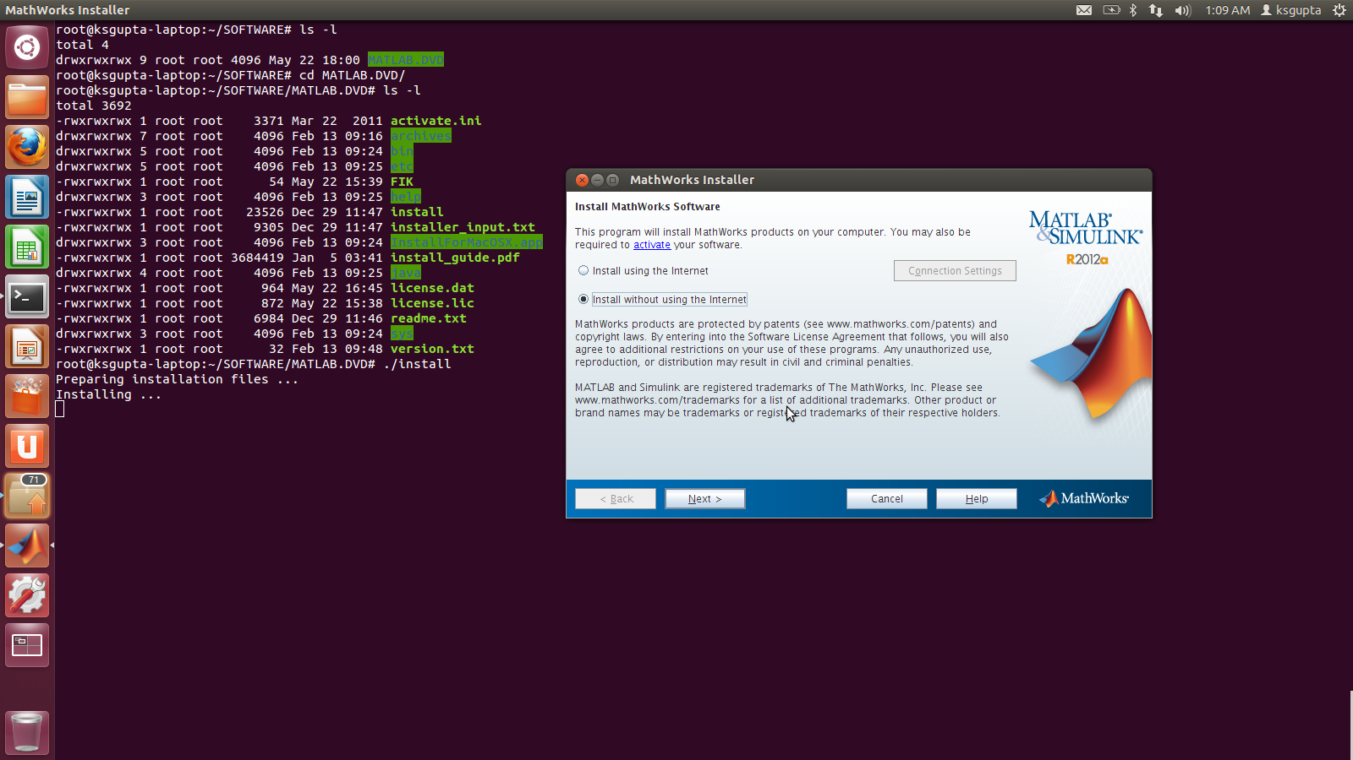
Screenshot1

Select “yes” for the license agreement and click Next. (screenshot2)
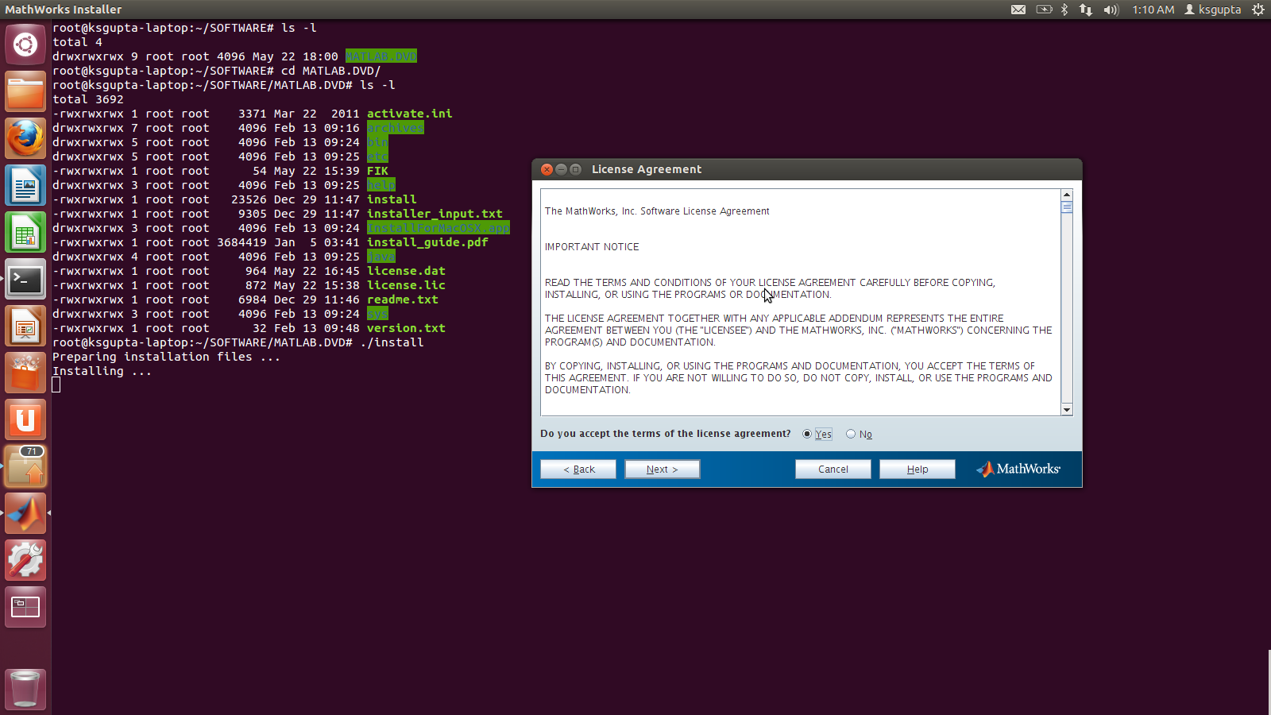
screenshot2

Now select “I have File Installation Key for my license” and put the value “33277-41047-22308-22586” in the bar as shown in the picture and click Next.(screenshot3)
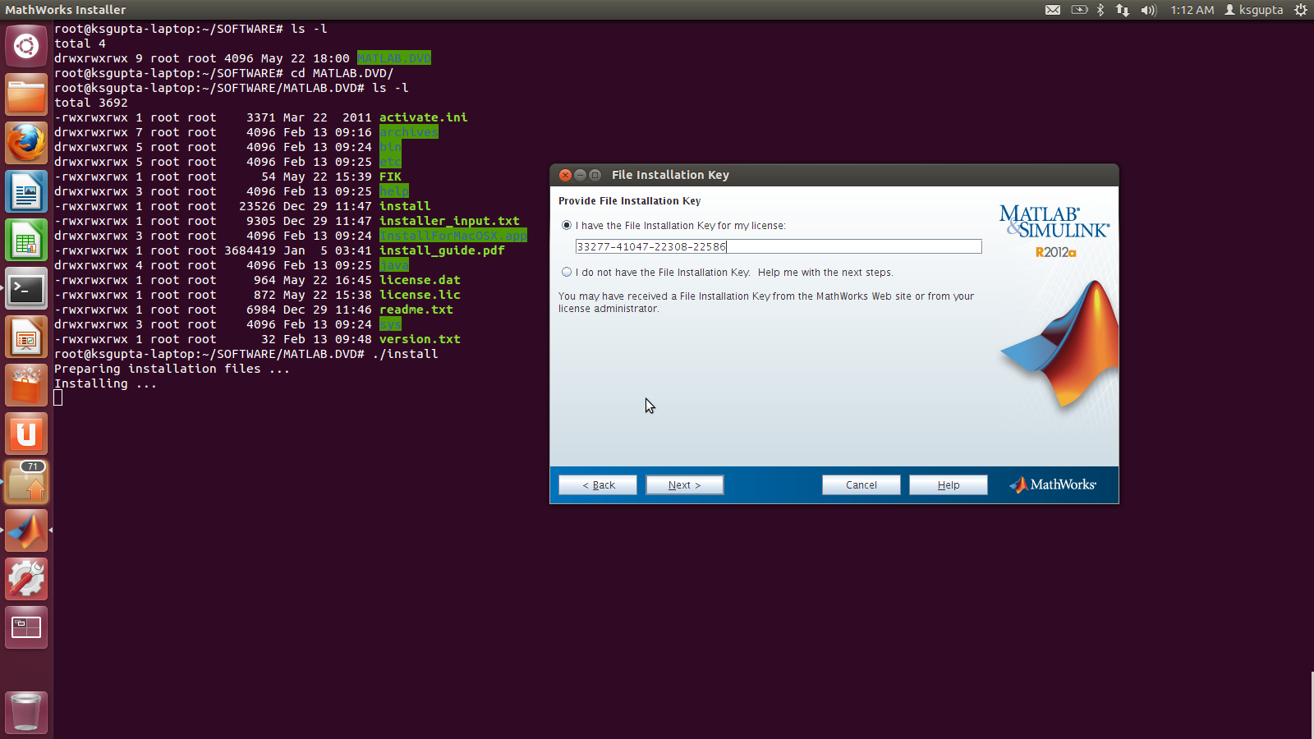
screenshot3

Select the installation type “Typical” and click Next.(screenshot4)
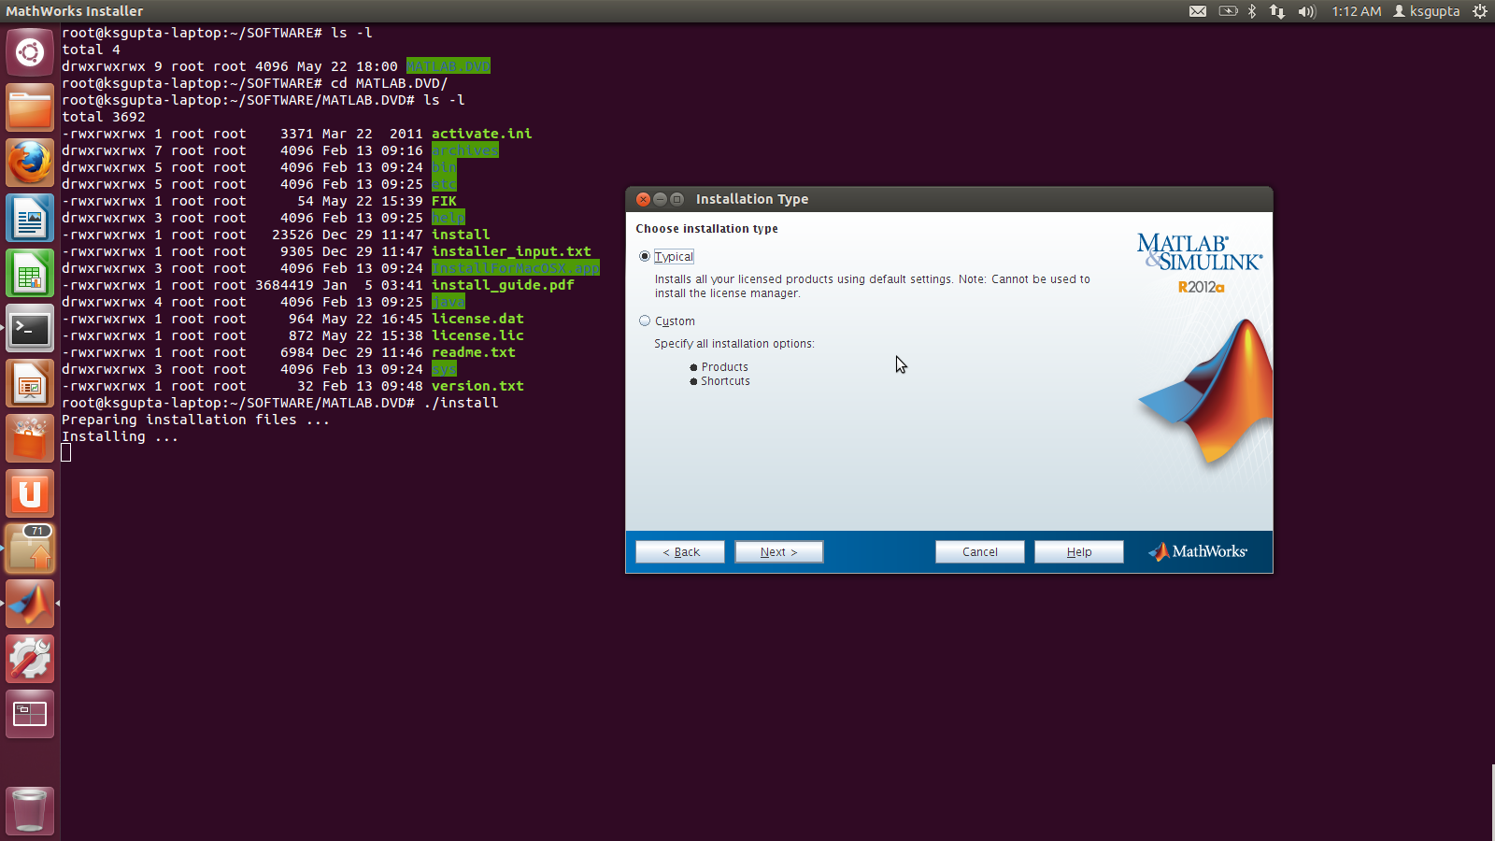
screenshot4

Now enter the full path to the installation folder .To install in the default path click next or select the location as per your choice. The picture shows the default location i.e “/usr/local/MATLAB/R2012a” . click next. (screenshot5)
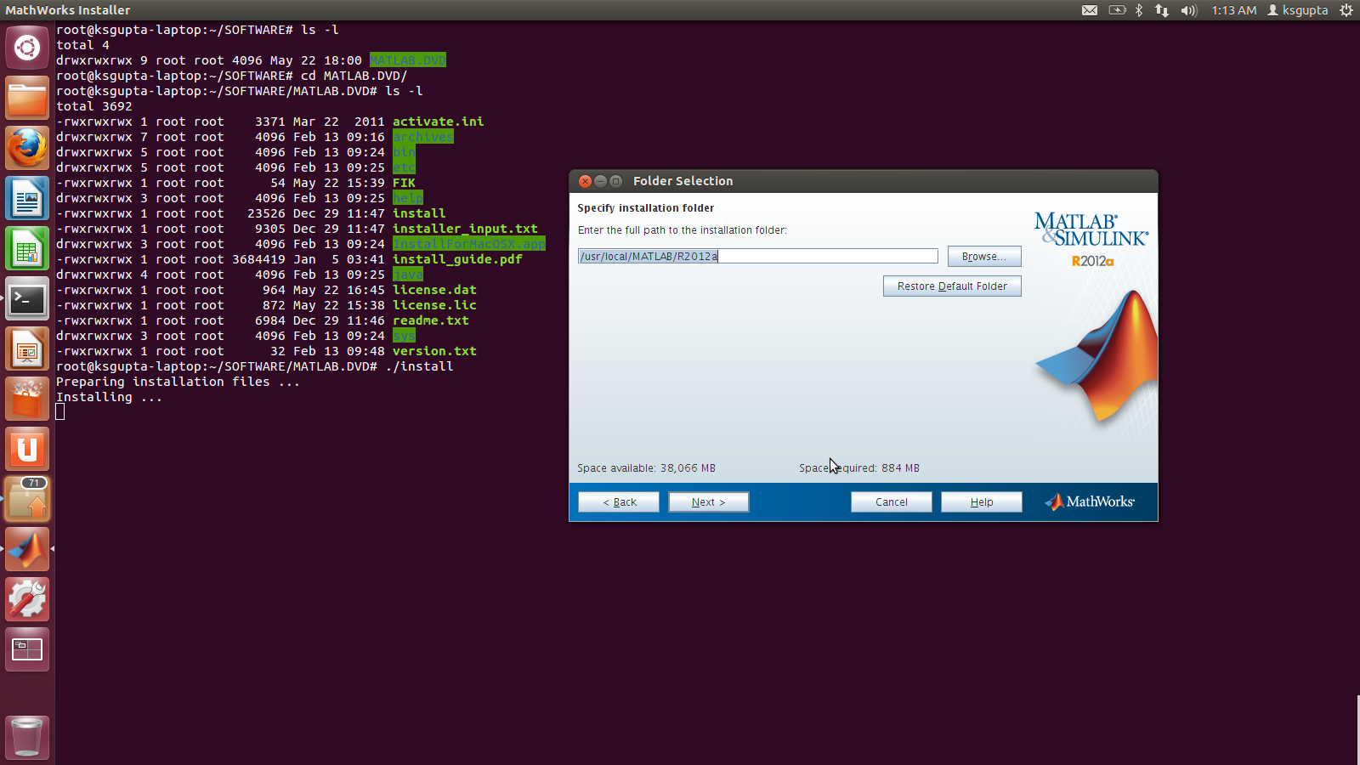
screenshot5

Click Yes to create the folders (screenshot6)
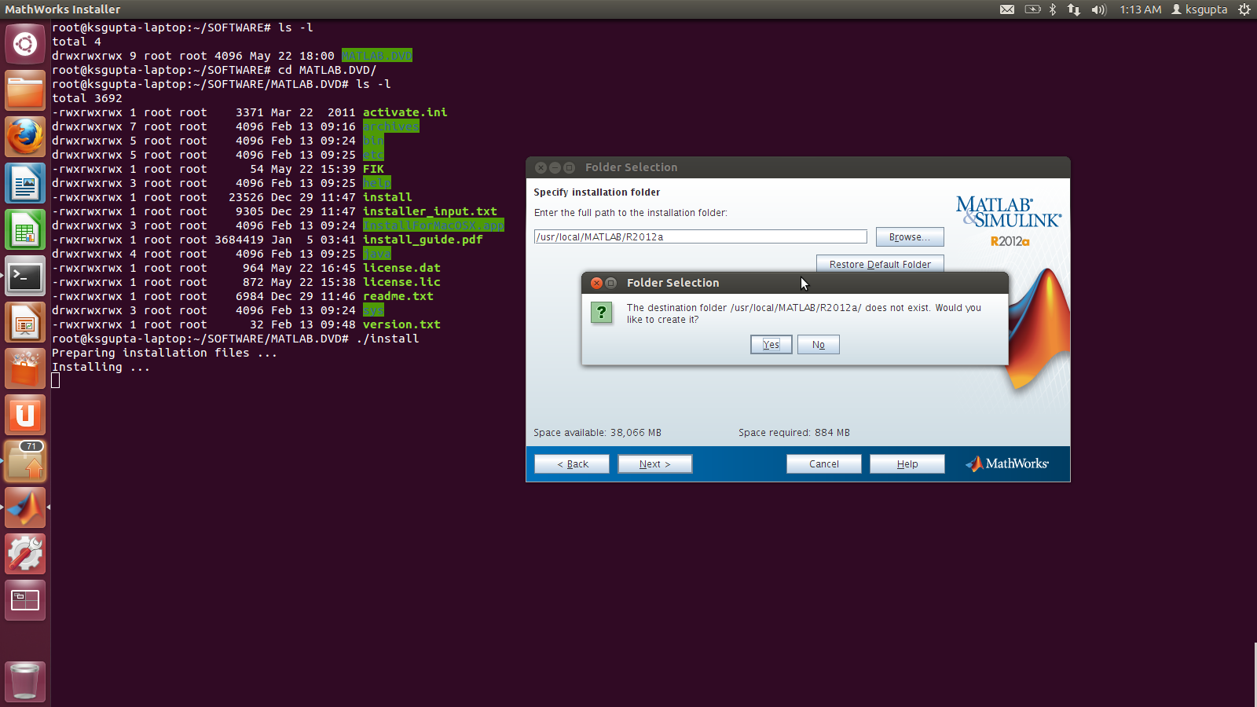
screenshot6

Now select the full path of the “license.dat” file which is located in “MATLAB.DVD” directory in your local machine (eg: /home/ksgupta/SOFTWARE/MATLAB.DVD/license.dat) and click Next.(screenshot7).
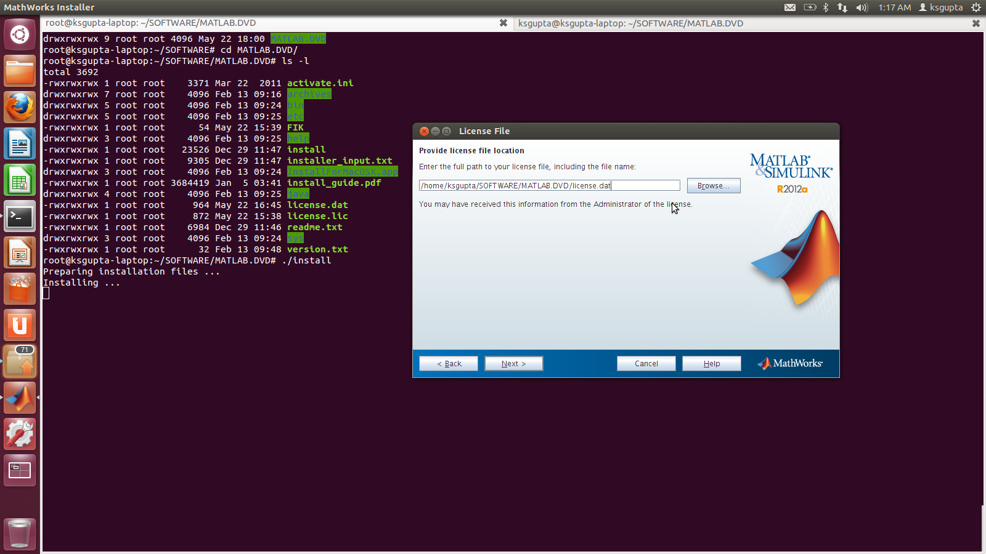
screenshot7

Now click “Finish” to complete the installation.(screenshot8)
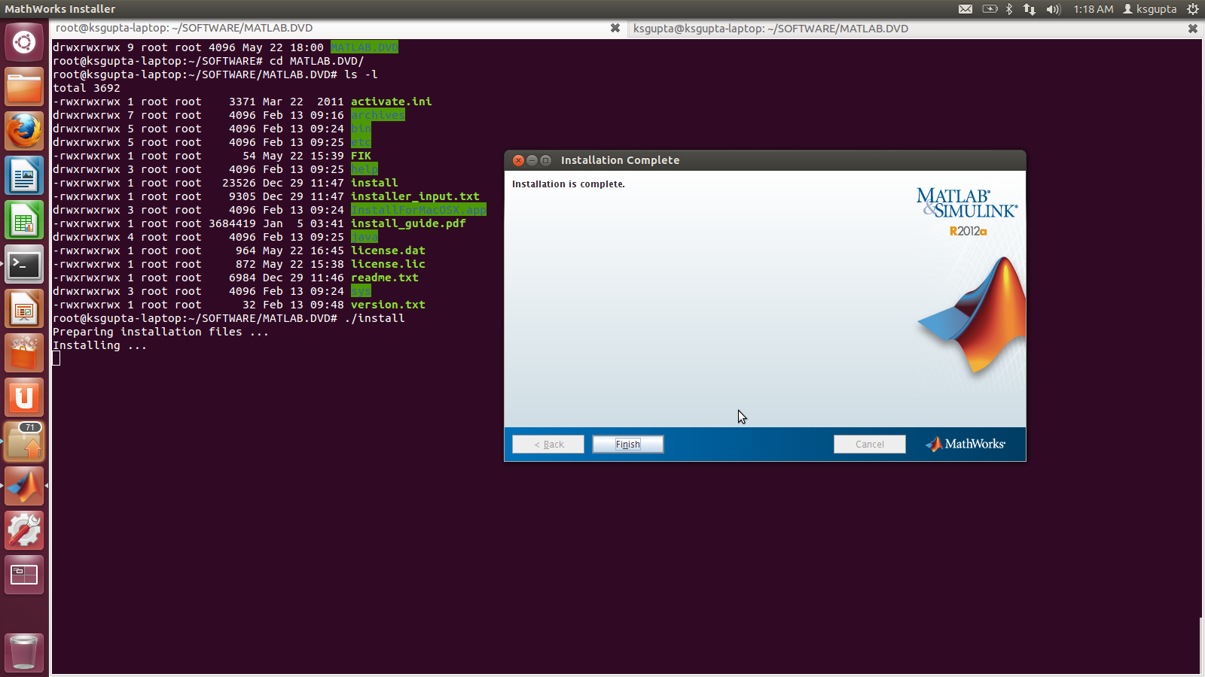
screenshot8

Step3: Now go to the “lincenses” directory where matlab was installed (eg: #cd /usr/local/MATLAB/R2012a/license) and open the “network.lic” file with gedit (or any other editor) and replace “chandra.saha.ac.in” with its ip “172.16.2.220” and save.

#gedit network.lic

Step4: Now go to the directory where matlab has been installed and there under the “bin” directory (eg: cd /usr/local/MATLAB/R2012a/bin) start matlab by using the below command.

#./matlab

OR

a small script named “matlab” can be written and saved in the “/bin” directory and MATLAB can be invoked only by typing “matlab” command from the terminal.
i)Log in as root.
ii)Go to the “/bin” directory and create a file with “vi” or any other editor and name it “matlab”.Insert the below commands in it and save.
Eg:
#cd /bin
#vi matlab (press “enter” to create the file and press “i” to insert the below commands in it)
cd /usr/local/MATLAB/R2012a/bin;
./matlab;

Now press “Esc” and then press “:wq” to save and exit.
Iii)Now change the permission of the “matlab” file created under /bin directory.
Eg:
#chmod 774 matlab
iv)Invoke matlab by typing only “matlab” from the terminal .
Eg:
#matlab

