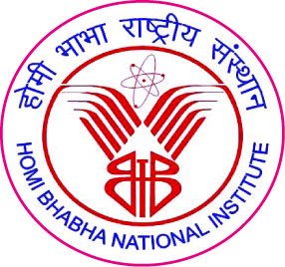

Homi Bhabha National Institute

Ph. D. PROGRAMME

Evaluation report on suggested Self Study Course

Name of the Student:

- Name of the Constituent Institution:

3. Enrolment No. and Date of Enrolment:

4. Title of the Thesis:

5. Subject & Syllabus (max 4 lines) of Self Study Course:

6. Date of Meeting for Evaluation:

Report of Doctoral Committee

Marks

Marks obtained: /100

S. No. | Name | Designation | Signature | Date
1. |  | Chairman
2. |  | Guide & Convener
3. |  | Co-guide (if any) / Member
4. |  | Member
5. |  | Member
6. |  | Member
7. |  | Technology  Adviser
- Doctoral Committee:

Dean-Academic

To
Dean, HBNI

Student has to go through reading materials as per the syllabus of the subject in the subject prescribed to him by the Standing Academic Committee/ Doctoral Committee and make a short presentation before the doctoral committee followed by question answer session.
For evaluation of Self Study Course, doctoral committee should critically judge student’s depth of understanding on the subject. Doctoral committee may give assignments to the students to ensure that the student has no weak spots.
If score is < 50, doctoral committee has to re-evaluate the student or prescribe an assignment to be evaluated by a member of the doctoral committee.

