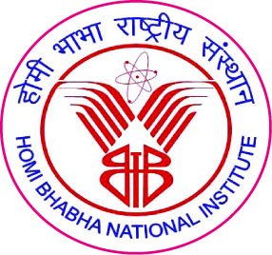

Homi Bhabha National Institute

Ph. D. PROGRAMME

Evaluation report on suggested Credit Seminar

Name of the Student:

- Name of the Constituent Institution:

3. Enrolment No. and Date of Enrolment:

4. Title of the Thesis:

5. Topic of Credit Seminar:

6. Date of Meeting for Evaluation:

Report of Doctoral Committee

Marks

Marks obtained: /100

S. No. | Name | Designation | Signature | Date
1. |  | Chairman
2. |  | Guide & Convener
3. |  | Co-guide (if any) / Member
4. |  | Member
5. |  | Member
6. |  | Member
7. |  | Technology  Adviser
- Doctoral Committee:

Dean-Academic

To
Dean, HBNI

A credit seminar is different from Self Study Course. It could be a minor research project that can be completed in about a month, or a critical review on a topic in an area allied to the subject of research chosen by the student for research. Student has to submit a report and make an oral presentation before the doctoral committee.
For evaluation of credit seminar, doctoral committee should critically look into the content, presentation quality and student’s depth of understanding.
If score is < 50, doctoral committee has to re-evaluate the student or prescribe an assignment to be completed by a member of the doctoral committee. .

